|  |  |  |  |  |  |  |
| --- | --- | --- | --- | --- | --- | --- |
| **Document No:** VOD-MAN-PRC-0488 | | Decommission Server CI Record | | | | **Rev. 2.3** |
| **Applicable areas of business**  Enterprise IT Division | | | **Responsible Division**  Enterprise IT Division | | | |
| **Approval** | **Name and Job Title** | | | **Approval** | **Approved Date** | |
| **Owner** | Jannie Pretorius | | |  |  | |
| **Approval by** | Mike van den Berg – Manager:  Service Management Enablement | | |  |  | |
| **Approved by** | Trevor Owen EHOD: Enterprise IT | | |  |  | |

Table of Contents

1. INTRODUCTION 1

2. GOALS 1

3. OBJECTIVES 1

4. APPLICABILITY 1

5. SOLUTION 1

6. HIGH LEVEL PROCESS 2

7. DETAILED PROCESS 2

8. PROCESS RACI 3

9. TEMPLATES / REFERENCE DOCUMENTS 3

# INTRODUCTION

This process will be used to decommission a server CI record in the CMDB. The process will focus and Historical Server CI records and well as existing (Active Servers in the Infrastructure that are earmarked to be disposed) infrastructure CI Records.

Following the Change Control process for decommissioning servers is the Vodacom preferred method as this will assist change management managing the risk and impact of the infrastructure.

After a successful decommission the server CI (In the CMDB) record Life cycle status will be set to “Disposed” , the record will be soft deleted. (Not visible for any another process module in the CMDB)

# GOALS

The goals of this process is to update the CMDB with relevant and accurate information.

# OBJECTIVES

Updating of the Server CMDB CI records to a decommission state after server has been decommissioned

# APPLICABILITY

This process is applicable to all CI Owners of Sever that are recorded in the CMDB.

# SOLUTION

Applicable solutions: Remedy Asset Management, email and Change request records.

# HIGH LEVEL PROCESS

**Change Requester**

1. Obtain the Server CI Name in question
2. Execute the Decommission Change Request for infrastructure servers
3. Ensure that all the effected CI’s are related to the change request.

**Note**: *Configuration will only act on the CI related to the change control and not to the Notes or summary fields in the change control*

**System Administrator executing the Decommission task**

1. Decommission the server in the Vodacom Infrastructure
2. Ensure the Server DNS have been updated
3. Update the Change Decommission task to Complete (This is to confirm that all the task above is done)

**Change office responsibilities towards the decommission**

1. Ensure the approvals are obtained
2. Ensure the risk of the decommission is determined
3. Ensure that the decommission and associated task (example Server IP address removed from DNS) are executed.
4. Instruct (Via the completion of the Change Decommission Task) Configuration Management to decommission CI Record.

**Configuration Management**

1. Update the server/s CI Record
2. Accept or Reject the Request / Change task to decommission
3. Communicate any rejections or the change Office or requester
4. Communicate any other anomalies to the change office

# DETAILED CHANGE REQUESTER PROCESS

**Note** : *Please communicate with Change management Office if you have any Questions to the process below.*

**There are two key steps in Remedy for submitting a change request to decommission a server.**

|  |
| --- |
| 1. **Using the Correct Change Template:**  * Use the Remedy Change Template, “***Server Infrastructure >> Decommission >> Decommission Server****”*   (See Snapshot 1 below)   1. **Relating the Correct CI**  * When relating the Configuration Item to the change request it is important to select the correct server name. If the incorrect server is chosen, the incorrect server will be disabled in the CMDB, technology scans and other processes. |

**Snapshot 1**

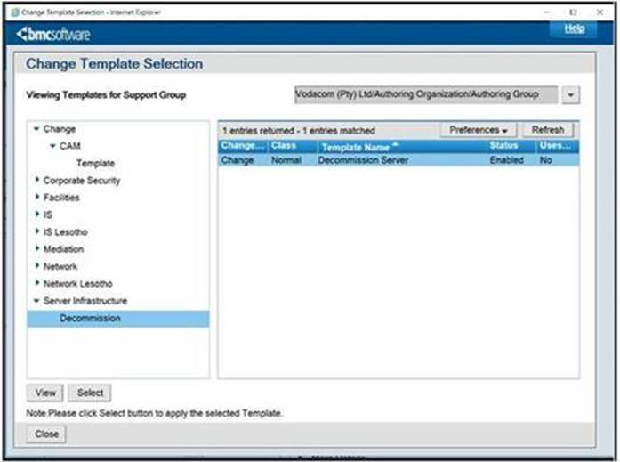

**Please note below, besides CMDB updates, there may be some tasks related to decommissioning which must be driven by the server owner/administrator as is there is no automated decommissioning process driver in place.**

|  |
| --- |
| * **Informing affected stakeholders to update relevant Systems and Databases**    + Topology, Inventory, Asset Management, Configuration Management and BCM/DRP etc.   + IT, Billing, Finance and Procurement Databases.   + Third Parties (Updating support contracts, SLAs and BoQs). * **CMDB/Remedy updates (Incident, Change, Asset Management etc)**   + Ensuring that CI’s are recorded as obsolete   + Removing redundant CI Approval and Notification Groups * **Removing configuration references of the decommissioned server** from other infrastructure/applications/databases (i.e. upstream/downstream, peer-peer, network/element management systems). * **License Management**   + Updating License Management Systems and/or Library * **IP Management**   + Management of IP Resources (Ranges), DNS maintenance * **Security Information and Event Management (SIEM)**   + Informing the SIEM operations departments (i.e. ArcSight, Splunk, etc.) to remove obsolete servers. * **Access Management**   + Informing UAM Support to remove obsoleted ARM Resources   + Informing UAM to remove resources from CyberArk * **SOX Controls**   + Informing the SOX Office of system changes that could influence the controls * **Etc…**  Other tasks as is relevant to each service area |

# PROCESS RACI

|  |  |  |  |  |  |
| --- | --- | --- | --- | --- | --- |
| ***Step#*** | ***Action*** | ***Responsible*** | ***Accountable*** | ***Consulted*** | ***Informed*** |
|  | Register the Required change and Relate all the CI | Change Requester | Line Manager | Change Requester Line management | N/A |
|  | Approve the change | CI Owner or proxy | Line Manager |  | N/A |
|  | Manage risk and Approvals and decommission task | Change Office | Line Manager | Change office | N/A |
|  | Instruct Configuration Management to change the CI Record after successful decommission | Change Office | Line Manager | Change office | N/A |
|  | Dispose the CI Record | Configuration Management | Line Manager | EIT Configuration Management Team | EIT Configuration Management Team |